Moonshot
Fuel-Free Lunar Export System



This report is based on factual evidence that supports the Research & Development of utilising the Moons properties to transport cargo back to earth without using fuel.

Copyright © 2026 (All Rights Reserved)
Author: Christopher John Rooney (BSc)
Illustrations: Grok/Microsoft Copilot
Moonshot: Fuel-Free Lunar Export System
Technical Benefits, Physics Basis, and Performance Calculations
(Prepared for concept evaluation and industrial feasibility review)
1. Executive Summary
Moonshot is a next-generation lunar launch and resource-return system that uses extreme rotational acceleration very similar in principle to the earth based “SpinLaunch” which ejects payloads at orbital and escape velocities without chemical propellant, but on the Moon where gravity is 1/6th of Earth’s and the atmospheric drag is zero.
This method becomes dramatically more efficient, enabling continuous, low-cost export of lunar materials such as metals, rare minerals, and helium-3. This document outlines the system’s benefits, physics calculations, and operational implications for a future lunar economy.
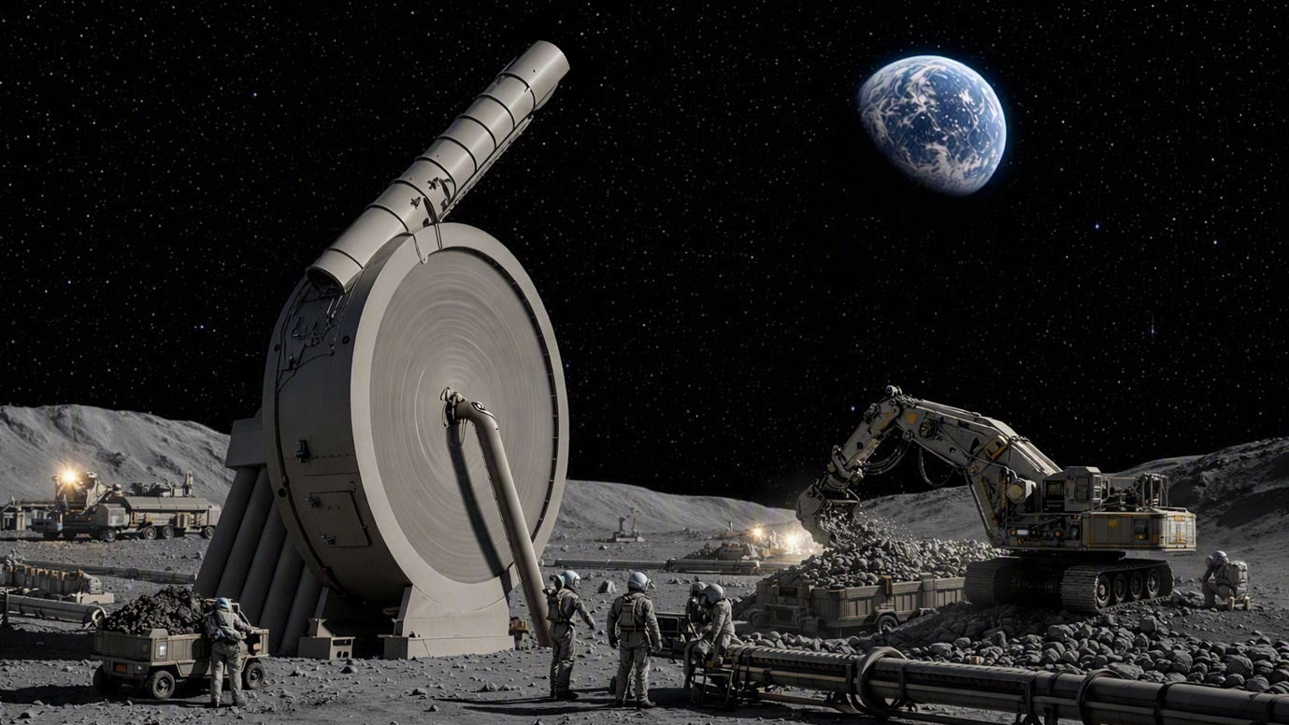
Figure 1, Stylised vision of the Moonshot

2. Lunar Environment Advantages
2.1 Lunar Gravity
The Moon’s surface gravity is:
$$g_{\text{Moon}}=1.62 {\text{m/s}}^{2}$$
Compared to Earth:
$$g_{\text{Earth}}=9.81 {\text{m/s}}^{2}$$
Thus:
$$\frac{g_{\text{Moon}}}{g_{\text{Earth}}}=0.165$$
This reduced gravity dramatically lowers the required escape velocity and structural loads on the launcher.

2.2 Escape Velocity
Moon escape velocity:
$$v_{\text{esc, Moon}}=2.38\text{ km/}\text{s}$$
Earth escape velocity:
$$v_{\text{esc, Earth}}=11.2\text{ km/}\text{s}$$
Implication: A spin-launcher must deliver only 21% of the velocity required on Earth.

2.3 Zero Atmosphere
The Moon has no atmospheric drag, meaning this makes rotational launch systems far more efficient than on Earth.
- No aerodynamic heating during launch
- No energy loss from air resistance
- Perfect ballistic trajectories
- No need for aerodynamic shaping of the launcher exit

3. System Overview
Moonshot uses a massive electromagnetic or mechanical spin-launcher embedded into lunar regolith. Payload capsules are accelerated to escape velocity and fired directly toward Earth. The system is powered entirely by solar-derived electrical energy, eliminating propellant dependency.

4. Physics & Engineering Calculations
4.1 Required Launcher Radius
To reach escape velocity using rotational acceleration $v=ωr$
Where:
- $v$= 2.38 km/s
- $r$= launcher radius
- $ω$ = angular velocity
Assuming a feasible angular velocity of $ω=100\text{ rad/}\text{s}$
Then:
$$r=\frac{v}{ω}=\frac{2380}{100}=23.8 \text{m}$$
Note: A 24-meter radius launcher is physically reasonable for lunar construction, you could increase the size to reduce the G-Force. However, a smaller system with high G’s has no effect on ejected raw materials. Helium-3 is an inert gas whereas SpinLaunch on earth at this amount of force would crush electronics. That’s why SpinLaunch has to be larger in scale, to keep the G-Force down.

4.2 G-Force on Payload
Centripetal acceleration $a=ω^{2}r$
$$a={\left(100\right)}^{2} x 23.8=238,000 {\text{m/s}}^{2}$$
Convert to G-forces:
$$G=\frac{a}{g_{\text{Earth}}}=\frac{238000}{9.81}=24,250 G$$
Payload capsules must withstand 24,250 G, consistent with high-G mechanical systems and rugged material capsules.
4.3 Energy Required per Launch
Kinetic energy:
$$E=\frac{1}{2}mv^{2}$$
For a 10-kg capsule:
$$E=0.5 x 10 x {\left(2380\right)}^{2}=28.3\text{ M}\text{J}$$
Solar arrays on the Moon receive:
$$1361 {\text{W/m}}^{2}$$
A 100-m² solar farm produces:
$$≈136\text{ k}\text{W}$$
Time to accumulate 28.3 MJ:
$$t=\frac{28.3 x {10}^{6}}{136000}=208=3.5\text{ mi}\text{n}$$
Average power needed for a given launch cadence:
$$P=\frac{E}{t}$$
Step 1: Pick a launch cadence
Let’s look at two realistic examples, however, these calculations only cover the Launch, power is also required for controls etc so I would add an additional 70% to the following calculations.
1 launch per hour
$$P=\frac{28.3 x {10}^{6}\text{ J}}{3600\text{ s}}=7.86\text{ k}\text{W}$$
1 launch every 10 minutes
$$P=\frac{28.3 x {10}^{6}}{600}=47.2\text{ k}\text{W}$$
Step 2: Assume a panel rating
Let’s assume modern 500 W panels (roughly 2 m² = 20 – 22% efficient). On the Moon, with 1361 W/m² and no atmosphere, that rating is conservative. Now, let’s say the power per panel is $0.5\text{ kW}$ (500 Watts).

Step 3: Calculate number of panels
For 1 launch per hour = 7.86 kW
$$N=\frac{7.86\text{ kW}}{0.5\text{ kW/panel}}=16\text{ panel}\text{s}$$
For 1 launch every 10 minutes = 47.2 kW
$$N=\frac{47.2}{0.5}=95\text{ panel}\text{s}$$

Conclusion
A modest solar array can power multiple launches per hour, supporting industrial-scale export. However, as previously discussed add 70% additional power for controls etc. Still, the numbers are relatively low for something that removes expensive fuel from the equation.
- Low-rate Moonshot (1 launch/hour): 16 + 70% = 27 panels
- Industrial-scale (1 launch/10 min): 95 + 70% = 161 panels

5. Earth Re-Entry System
Moonshot capsules perform a multi-stage deceleration sequence:
5.1 Atmospheric Aerobraking
Capsule shape + heat shielding dissipates velocity using drag. This replaces retro-rockets entirely.
5.2 High-G Structural Integrity
Capsules already survive extreme launch G-forces, making them naturally robust during re-entry.
5.3 Parachute Deployment
After aerobraking reduces velocity to subsonic levels, parachutes deploy for safe landing and recovery.

6. Strategic Benefits
6.1 Zero Fuel Requirement
No chemical propellant for launch or landing. All energy comes from solar power.
6.2 Massive Cost Reduction
As of 2026 chemical rockets cost £2,000–£6,000 per kg to launch from Earth. Moonshot could reduce this by orders of magnitude.
6.3 Continuous Export Capability
Multiple launches per day enable steady supply chains.
  - Industrial-Scale Lunar Mining
Materials such as Helium-3, rare metals such as platinum, titanium and aluminium oxides all become economically viable to export.
6.5 Closed-Loop Logistics
Solar energy → launch → re-entry → recovery → repeat.
6.6 Foundation of a Lunar Economy
Moonshot becomes the backbone of:
- Lunar mining
- Off-world manufacturing
- Resource export
- Energy supply chains
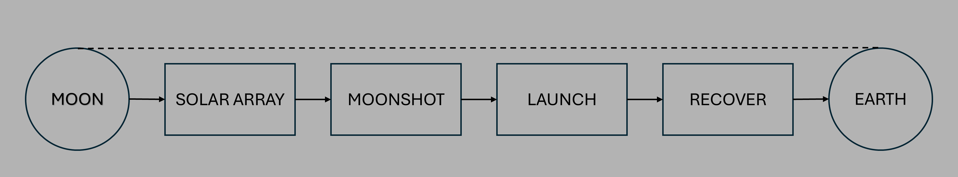
- Interplanetary commerce
Figure 2, Schematic Diagram

7. Conceptual Impact
Moonshot transforms the Moon from a distant destination into a functional industrial partner, enabling sustainable, low-cost resource flow to Earth. It is not merely a launch system; it is the infrastructure of a future lunar economy.
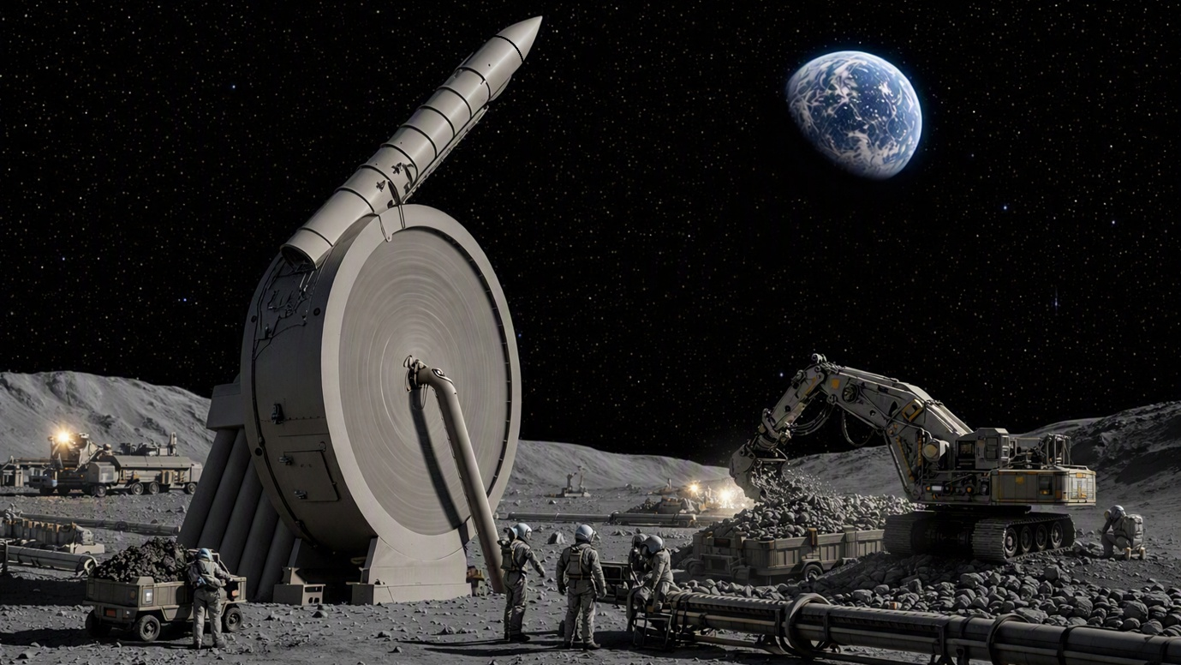
Figure 3, Stylised vision of the Moonshot 2

