**Engineering Design Methods**

**Coursework 2**

**Racing Kart Stub-Axle & Bearing Assembly**

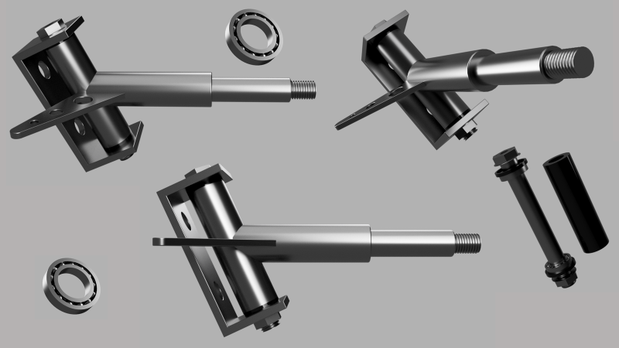

**By Kenny & Chris**

# **Contents**

Contents 2

List of Figures 2

List of Tables 2

Introduction 3

Aim 3

Objective 3

Design Consideration 3

Considered Mechanical Properties 3

Note 3

Function and Failure of Component 4

Types of Stub Axle 4

How to Know When Your Axle Is in Disrepair 4

Effect of Failure 5

Welding 5

FMECA Chart 6

FMECA Conclusion 6

Casting Method 6

Stub Axle Fault Tree 7

Go-Kart Calculations & Assumptions 8

Stub Axle Cast Dimensions 9

Calculations & Dimensions 10

Conclusion 10

Reference 11

## **List of Figures**

Figure 1 Weld Weakness 5

Figure 3 Fault Tree 7

Figure 4 Stub Axle Dimensions & Components 9

Figure 5 Stub Axle & Hinged Bolt 10

## **List of Tables**

Table 1 Types of Stub Axle 4

Table 2 FMECA Chart 6

Table 3 Calculations & Assumptions 8

# **Introduction**

This report is to analyze the Stub Axle of a Go-Kart, the report will critically detail the problem with the Stub Axle design by means of a Failure Mode, Effects, and Criticality Analysis (FMECA) chart, and Boolean Fault Tree. Methods selected give an easier understanding of the faults and potential problems. From the (FMECA) and Fault tree, improvements can be made to the Stub Axle design. Research, hand calculations and a schematic diagram of an alternative solution will be put forward involving a critical conclusion, whilst key components will be fully justified regarding the redesign. The most important factor to remember is the Stub Axle has to be safe, this component is critical regarding vehicles in general, failure can ultimately lead to death.

**Keywords: Stub-axle; Bearing; Failure; Critical; Safety.**

## **Aim**

The purpose is to optimize the working & performance of the racing kart stub-axle and bearing assembly.

## **Objective**

To design a kart stub-axle and bearing assembly that is stable and safe.

# **Design Consideration**

Racing Karts are often defined to be a land vehicles either with or without a body frame with four non-aligned wheels in reference to the track width. two of the wheels control the steering whilst the opposite transmits power that propels the Go-Kart. Go-kart systems are typically powered by electrical motors or gasoline engines. The chassis consists of steel pipes that are ductile and strong in the absence of a suspension system. They can be adjusted to suit a suspension function allowing for the Go-Kart to be durable when absorbing the impact of terrain. (Sangeetha K. October 2020)

## **Considered Mechanical Properties**

* Density (Kg/m3)
* Elastic modulus (GPa)
* Tensile Strength (MPa)
* Yield Strength (MPa)
* Poisson’s ratio
* Elongation (%)
* Newton Forces (N)

## **Note**

In order to design a Stub Axle, Newtonian forces (N) applied whilst driving, specifically turning at speed will determine the specification of the Stub Axle design.

# **Function and Failure of Component**

An axle is a rod that supports the rotation of wheels and supports the load of your vehicle which may even be said to be a central shaft for a [rotating](https://en.wikipedia.org/wiki/Rotation) wheel or gear. Axles are vital components of any vehicle, available in three main types: front, rear, and stub. This suggests the wheels and tyres are rigidly connected to its frame.

For a front wheel drive, Stub Axles are attached to the vehicle's front wheels and chassis and controlled by the steering arm. The kingpin secures the Stub Axle whilst allowing rotation of the wheels. The Stub Axles main function is to hold the wheel in position whilst allowing the vehicle to turn. They can breakdown and deform under force and stresses over time, induced by the repetitive compressive load on the upper edge and tensile stresses on the lower. This happens because the wheel experiences a high impact load in the upward direction. Therefore, this outcome generally happens when a vehicle is turning at speed known as the lateral force. The probability of failure is higher due to the impact failure of welded joints.

looking deeper into the probability of failure, the steering arm can fail from two places, one is from welded joints, the with other is the swivel joint on the far end where it is connected to the steering rod. The probability of failure regarding the swivel joint is higher because it putatively undergoes excessive wear as the vehicle is constantly turning/cornering. The steering arm is shorter than the track width by design. This creates on average a 30-40 degree turning circle. This is where the lateral force builds denoted as the Stub Axles nemesis.(Axletech.com 2020) (fluviatilis et al., 2020)

## **Types of Stub Axle**

Table 1 Types of Stub Axle

|  |  |
| --- | --- |
| **Elliot** | This sort of axle is attached to the front axle which uses a kingpin, a yoke, and a cotter to attach to the front axle. It goes to the wheel hub and is a steerable part while the front axle remains motionless. |
| **Reverse Elliot** | This sort of axle has the other arrangement of a standard Elliot stub axle i.e. structure of the upright. |
| **Lamoine** | This stub axle types whose structure is in an L-shaped spindle rather than of a yoke-type hinge. |
| **Reverse Lamoine** | It is the other layout of a typical Lamoine stub axle. |

## **How to Know When Your Axle Is in Disrepair**

Axles are essential components to a car's operation; it is vital to keep them working. If you notice one of the following signs during driving or maintenance services, you will know that your axle needs repair:

* You hear a loud clunk once you change the gear of your car.
* You feel vibrations once you operate your car.

Since chassis behaviour and set-up vary, the Stub Axle has to flexible. It is interesting to observe what happens when axles have different mechanical properties. Of course, to ensure top performance, any axle has got to have good elasticity power to return to its former shape after flexing. (Types of Axles: Everything You Need to Know, 2020)

# **Effect of Failure**

The effect of such failure regarding the Stub Axle is severe, the expected cause of failure and its effect regarding operational conditions is assumed to be the under worst case scenario. System failure is to be analysed in terms of safety and reliability. The probability of failure is either wearing of the rolling element, or misalignment of the bearings which may be a result in failure regarding the bearing spacer. The system effect arises when turning at speed giving a harsh operational environment. Although, the probability of failure is higher due to the impact of welded Joints, this can cause the intense safety effect. The Stub Axle rod houses the bearing, this subassemblies main function is to reduce the friction that is ever present and also provides bearing support. Conceivable failure is detected by testing during maintenance, this is shown as part of the FMECA worksheet. (Failure Mode Effect and Criticality of Stub Axle…| Bartleby, 2020) (Acasestudy.com 2020)

## **Welding**

The redesign of the Stub Axle will remove the welds, welds are a weak point, in many cases Stub Axle failures result from broken welds leading to breakdown of the component. To over come this obstacle a one-part cast Stub Axle solution will be designed. This removes the weakness of a weld; it also eliminates human era as most Go-kart Stub Axles are manually welded together. The casting method approach gives consistent accuracy and improves strength. Welding a Stub Axle together consists of combining three parts together. The 25-degree bearing house, wheel hub shaft and steering connection plate, these hand welded parts lead to dangerous imperfections which crate problems specifically when a Go-Kart is subject to forces.

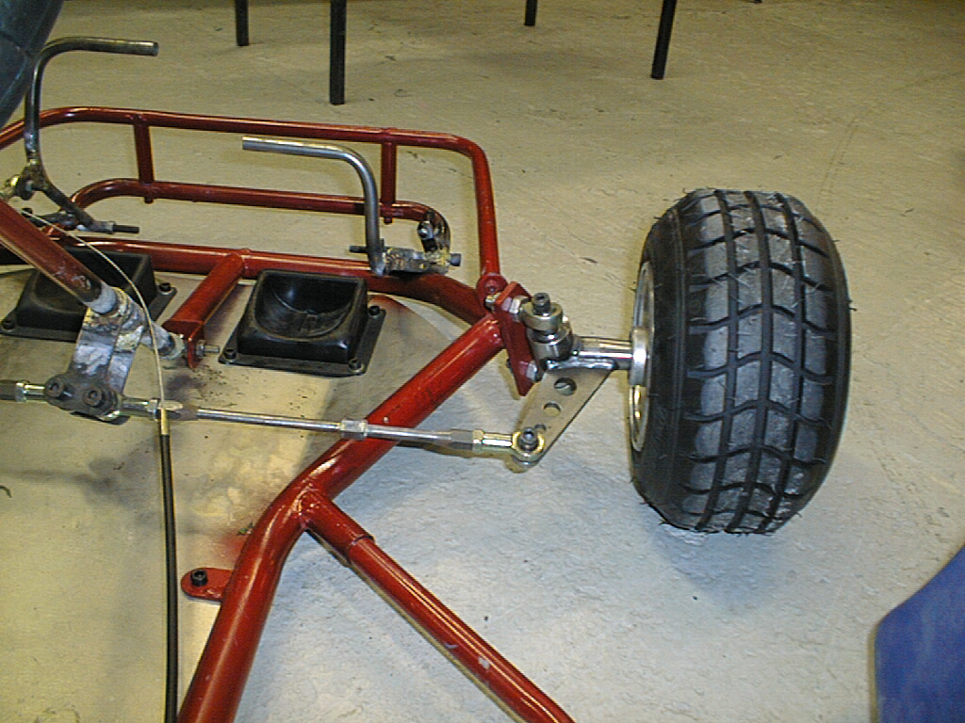 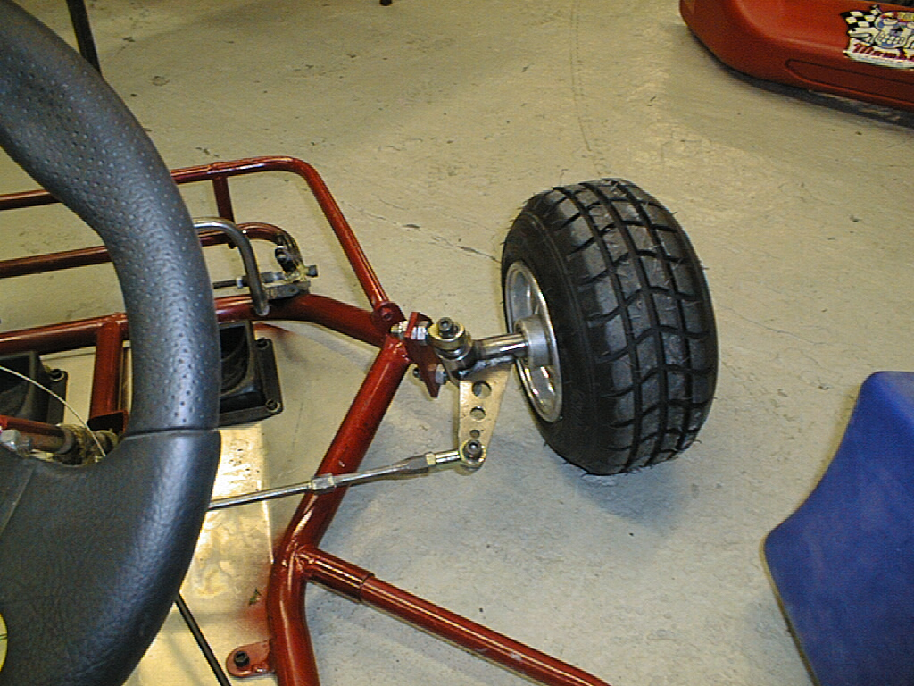

Figure 1 Weld Weakness

# **FMECA Chart**

Using Formula (Severity × Occurrence × Detection = RPN)

Table 2 FMECA Chart

|  |  |  |  |  |  |  |  |  |  |  |  |
| --- | --- | --- | --- | --- | --- | --- | --- | --- | --- | --- | --- |
|  |  | | |  |  | | | | |  |  |
|  |  | | | | |  |  |  |  |  |  |
| 1 | **Function (Verb/Noun)** | **Measurable** | **Failure Mode Type** | **Failure Mode Description** | **Potential Effect of Failure** | **Sev** | **Potential Cause of Failure** | **Prevention Control** | **Occ** | **Det** | **RPN** |
| 2 | Control the wheels, Transmit loads between the chassis and the wheels | Torque loads Nm | No Function | No transmission of any dynamic loads between interfacing components | Lose control of the vehicle | 10 | MATERIAL (PROPERTIES - Yield/UTS/Elongation) insufficient | Standards and design rules | 6 | 3 | 180 |
| 2 |  |  |  |  |  |  | WELDS - Designed weld criteria insufficient for load requirements | Standards and design rules | 6 | 3 | 18 |
| 3 |  |  |  |  | Wear of attached components and degraded ride and handling | 8 | FATIGUE - Fatigue life of the Link/Arm is insufficient for vehicle life | Standards and design rules | 3 | 3 | 72 |
| 4 |  |  |  |  |  |  | MATERIAL DEFECTS - or material processing / curing defects | Standards and design rules | 3 | 10 | 30 |
| 5 |  |  |  |  |  |  | Failed bolted joint | Standards and design rules | 8 | 3 | 24 |
|  |  |  |  |  |  |  | CORROSION at joint interfaces | Standards and design rules | 3 | 3 |  |
| 6 | Locates and supports other suspension components | Location - mm | Partial Function | Does not allow consistent location of suspension system architecture | Degraded ride and handling attribute | 8 | Inaccurate dimensional tolerancing | Standards and design rules | 3 | 3 | 72 |
| 7 | Twisting and turning of the wheel | Load Nm | Partial Function | When the suitable welding is not done, and material type is not chosen correctly | May lead to total collapse and vehicle vibrating | 6 | Design - Improper mounting and designing | Standards, analysis of material and design rules | 3 | 4 | 72 |
| 8 | House and Bearing subassemblies main function is to reduce the friction and provide bearing support. | Location - mm | Partial Function | It putatively undergoes excessive wear as vehicle takes turning. | Vehicle where operated with insufficient lubricant | 7 | WELDS - Maintenance practices and service procedure | Standards and design rules | 3 | 4 | 84 |
| 9 |  |  |  |  | Shear failure of either bolt or steering rod | 8 | Torsional shear | Standards and design rules | 3 | 2 | 48 |
| 10 | Stub Axle has the ability of angular movement about the kingpin for steering the vehicle. |  | Partial Function | Impact failure of weld joints | The vehicle might fail suddenly due to high impact | 7 | FATIGUE - It made be deformed due to high fatigue stress induced due to the repetitive compressive load on upper edge | Standards, design rules and performance check. | 3 | 4 | 84 |
| 11 |  |  |  |  | Bolted joints such that whole subassembly is linked with the steering rod by means of the swivel joint. | 7 | Tensile on lower edge as many times as the wheel experiences high impact load in upward direction | Standards and design rules | 3 | 4 | 63 |

## **FMECA Conclusion**

According to the results obtained from the FMECA work sheet, the values of criticality of two components that controls the wheel transmit loads between the chassis and the wheel are higher as compared to those of others. Since the delectability of failure of the wheel possesses high index it would be difficult to detect failure as it would fail suddenly due to high impact and the severity would undoubtedly be high, the whole assembly would dismantle causing breakdown. The probability of failure regarding the swivel joint is higher because of either repetitive wearing of bearing surface contact area, or the shearing off of the pivotal bolt Joining them. Severity is high since it causes breakdown of the system. So finally, the system safety and reliability depend mainly on these two parts, and therefore provisions are often made to minimize these values in new concepts.

## **Casting Method**

We consider using casting method rather than welding because it causes distortion due to heat for its failure. Casting are often costlier but on mass scale cheaper because it removes the welding machine and operator. Material selection is to be austempered ductile iron (ADI) which provides good fatigue, impact strength and ductility.

# **Stub Axle Fault Tree**

Fault tree using Boolean AND/OR shows the failures of a Stub Axle, from wear and tear, broken welds to mis guided information regarding design. When a product fails a number of scenarios lead to its demise.

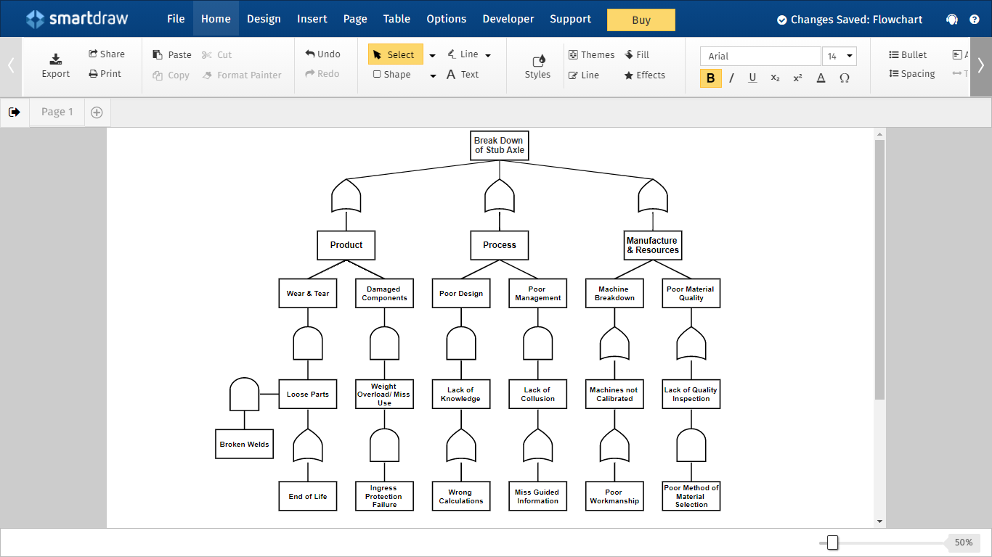

Figure 2 Fault Tree

The Fault tree determines what the new improved design should adhere to. Welds and welding machines are a problem to overcome, this method allows for era. However, the welding technique has been appointed by management. The lack of research and new technology capabilities has not been utilised. using the old school knowledge has led to the Stub Axle for a Go-Kart to be ill designed hence the weakness , regarding mass production it is not cost-effective method either. A critical component of this nature should be made from just one cast part and over designed to a certain degree increasing the safety factor. Especially for Go-Karts that exceed 40km/h.

# **Go-Kart Calculations & Assumptions**

Table 3 Calculations & Assumptions

|  |  |  |
| --- | --- | --- |
| Laden weight | 150kg |  |
| Vehicle weight rear | 90 Kg | 60% |
| Vehicle weight front | 60 Kg | 40% |
| Average Velocity 40km/h | 11.1m/s |  |
| Wheelbase | 1.2m |  |
| Wheel Track Width | 1m |  |
| Turning Radius (R) | 2.17m |  |
| Friction | µ = 0.7 |  |

**Ackerman Angle**

**Length of Tie Rod**

Steering Arm Length = 1m

m

Tied rod = 0.4m

**Turning Radius**

Assumed parallel-set steering arm layout. 20 degree turning radius for the inner and outer wheel left/right giving a total 40-degree angle. (The Ackermann Principle as Applied to Steering (Automobile), 2020)

**Force on Stub Axle**

Newton = Mass x Gravity

**Velocity at 40km/h**

**Lateral Force Stub Axle**

**Frictional Force**

**Conclusion**

Lateral Force is 3.4 kN, the Stub Axle needs to be designed to cope with high speed forces specifically when turning. A one-part cast rather than welded product would increase the overall strength and give a longer life span. (Jetir.org 2020)

# **Stub Axle Cast Dimensions**

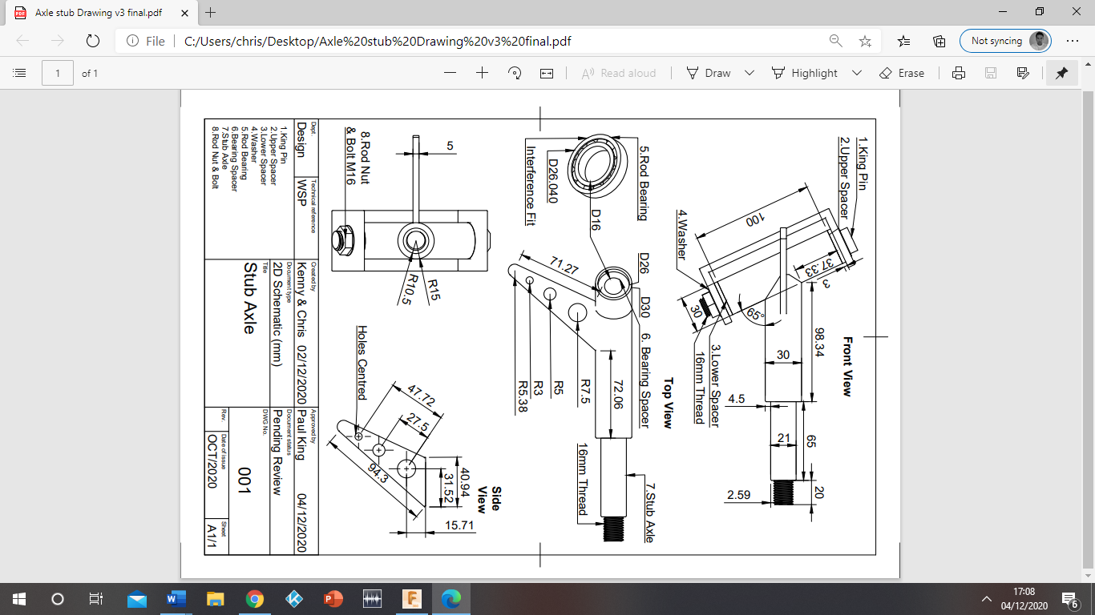

Figure 3 Stub Axle Dimensions & Components

## **Calculations & Dimensions**

Calculations have been made regarding a real-life scenario, the forces are the critical design factor, and the lateral force is the most important. Component must be able to with stand 3.4kN of force. Therefore, a robust one-part Stub Axle has been designed using ductile iron. The component is solid. The 25-degree offset (65-degree due to CAD axis) is the only hollow part and is attached to bracket which is bolted to the Go- kart rather than welded. However, a steel bearing spacer along with the king pin make this section solid which includes 2 x interference fit bearings (+0.04mm) for turning ability.

# **Conclusion**

After studying a Stub Axle for Go-Kart, it has been concluded that a one-part cast is the preferred method of manufacture. Taking information from research, FMECA data, fault tree analysis, and calculations it has been determined that the forces the Stub Axle is subjected to is high. Considering the severity of a potential fault and the potential outcome of that fault, a new stronger design has been put forward as a solution. A casted Stub Axle has no welds, therefore is stronger in design, more precise in design and cheaper on mass production whilst removing human era from the equation. Removing the human era also removes human emotion. If a Stub Axle is the reason for a fatality I would not want to be the person who carried out the work. Taking this into account the Stub Axle dimensions are purposely designed for longevity and heavy duty. For instance, the standard 10mm kingpin has been replaced with a 16mm gauge. The bracket that was welded to the chassis connecting the Stub Axle has been replaced with 6mm thick hinged bracket and is to be bolted to the chassis. Bolts can be retorqued and easily replaced, regular maintenance should be scheduled for a racing Go-Kart with a top speed of 50km/h with a lateral force of 3.4kN over the front wheels whilst the normal force is only 588.6N. Turning at speed is the main factor and cause of faults, therefore the design needs to be solid.

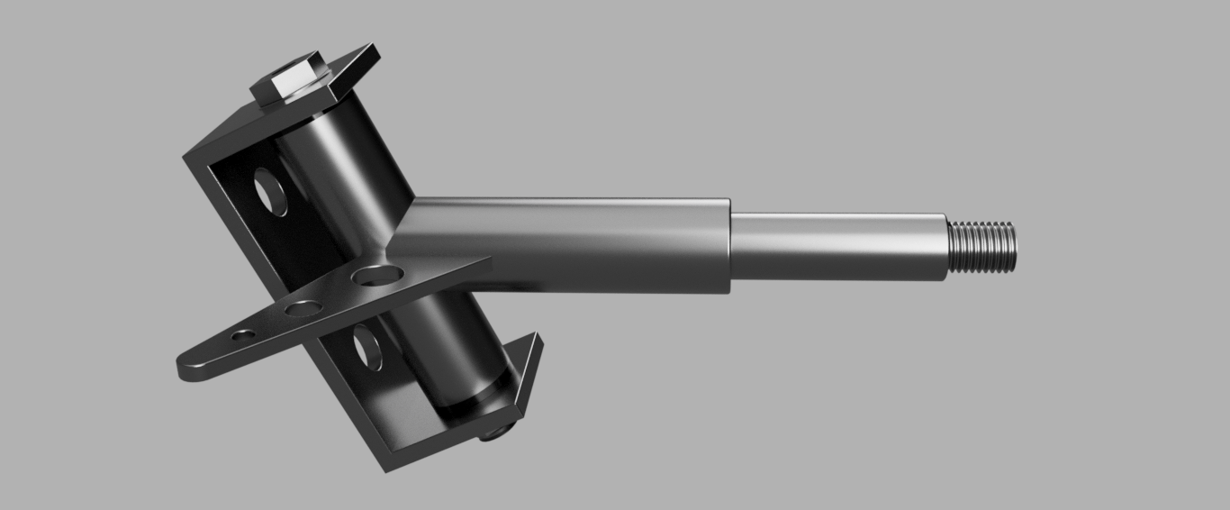

Figure 4 Stub Axle & Hinged Bolt

# **Reference**

“Design and analysis of electric Go-Kart” Available at: [https://www.sciencedirect.com/science/article/pii/S2214785320371297. [Accessed](https://www.sciencedirect.com/science/article/pii/S2214785320371297.%20%20%5bAccessed): 29 November 2020].

Axletech.com. 2020. [online] Available at: <https://www.axletech.com/at-admin/resources/Manuals/amt-0445d22018-09-07-reprint.pdf> [Accessed 4 December 2020].

fluviatilis, P., moschata, C., pepo, C., oils, g., pepo, C., Systems, I., transmission, b., reactions, m., materials, s. and effect, v., 2020. US8464611B1 - Modular And Adjustable Axle Systems For Vehicles - Google Patents. [online] Patents.google.com. Available at: <https://patents.google.com/patent/US8464611B1/en.> [Accessed 4 December 2020].

Car and Driver. 2020. Types Of Axles: Everything You Need To Know. [online] Available at: <https://www.caranddriver.com/research/a31547001/types-of-axle/> [Accessed 4 December 2020].

Bartleby.com. 2020. Failure Mode Effect And Criticality Analysis Of Stub Axle... | Bartleby. [online] Available at: <https://www.bartleby.com/essay/Failure-Mode-Effect-and-Criticality-Analysis-of-PKHY6SXH3GEZ> [Accessed 4 December 2020].

Acasestudy.com. 2020. [online] Available at: <https://acasestudy.com/failure-mode-effect-and-criticality-analysis/> [Accessed 4 December 2020].

What-when-how.com. 2020. The Ackermann Principle As Applied To Steering (Automobile). [online] Available at: <https://what-when-how.com/automobile/the-ackermann-principle-as-applied-to-steering-automobile/> [Accessed 4 December 2020].

Jetir.org. 2020. [online] Available at: <http://www.jetir.org/papers/JETIR18IC052.pdf> [Accessed 4 December 2020].