Staticomatic Project Proposal
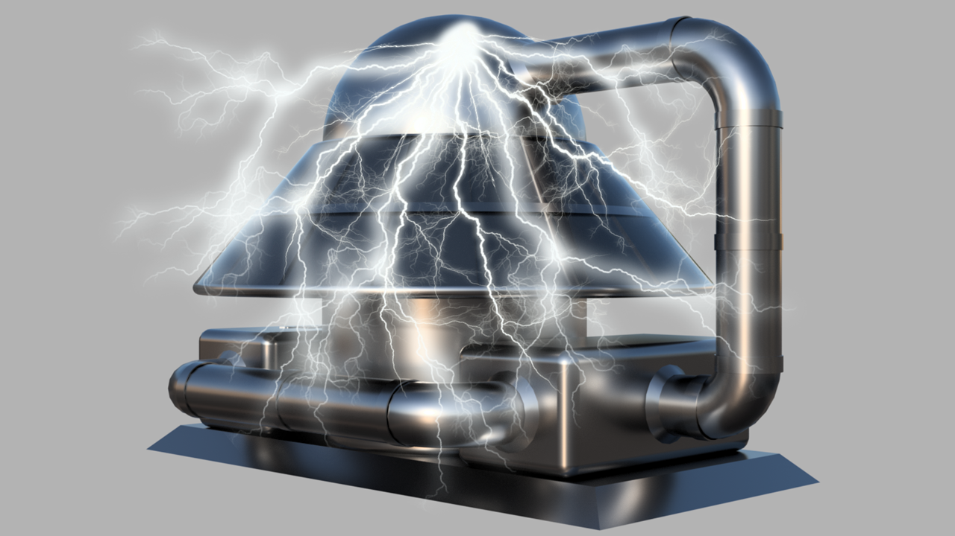
Figure 1 Vision

By Christopher John Rooney
www.roontech.co.uk

Contents
Staticomatic Project Proposal 1
Figures 2
Tables 2
Prototype Project Proposal 3
How it Works 3
Key Points About Plastics in Soil: 4
Types of Plastics in Agricultural Soils: 4
Particle Sizes of Plastic Contaminants: 4
Distribution of Studies: 4
Top Contributors of Plastic Waste: 4
Forms of Plastic Contaminants: 4
Distribution and Sources: 5
Prototype: 5
Traditional Method: 5
ROONTECH Method: 5
Prototype Education 7
Funding & Cost 8
Conclusion 8

Figures

Figure 1 Vision 1
Figure 2 How it Works 3
Figure 3 Static Charge 6
Figure 4 Compress-E-Bin 8

Tables
Table 1 Types of Plastic Contaminants 4
Table 2 Particle Sizes 4
Table 3 Distribution of Studies 4
Table 4 Top Contributors 4
Table 5 Forms of Contaminants 4

Prototype Project Proposal
Plastic pollution poses a significant threat to our environment, affecting soil quality, water systems, and human health. Staticomatic, an innovative technology developed by ROONTECH, offers a promising solution. This project proposal outlines the steps required to develop a Prototype and the educational benefits that ensue regarding the efficient removal of contaminated soil within the Global Agricultural Industry. Using Sustainable practices, the following Proposal has been developed which incorporates ROONTECH’S standard practice of creativity, empathy and outside of the box thinking.

How it Works
Staticomatic is a fascinating concept developed by ROONTECH. It addresses the issue of plastic pollution in soil using an innovative approach involving static electricity, here’s how it works.
Contaminated Soil: Soil contaminated with plastics is sent to a Heated Grinder System, where it is dried and reduced to dust.
Sieve and Vibration: The dust-like material is then transferred to a holding tank/silo. Materials pass through a mesh aided by vibration and fans, which help separate different materials.
Static Electricity: The inner walls of the holding tank/Silo are induced with high voltage supplied via solar arrays. As the materials fall the plastic particles are attracted to the static wall and stick whilst the soil particles fall freely.
Repeat Process: The process repeats until the batch of soil shows very low levels of contaminants. By removing plastics, Staticomatic contributes to environmental health and food security.
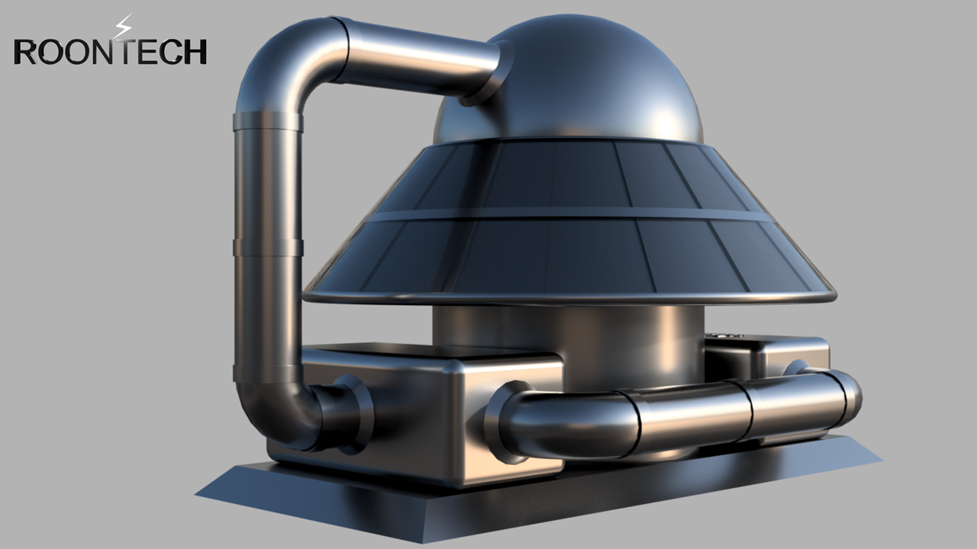
Figure 2 How it Works

Key Points About Plastics in Soil:
- Plastic waste accumulates in agricultural soils globally.
- Microplastics (particles less than 5 mm in size) infiltrate the soil, altering its physical structure and affecting water-holding capacity.
- Proper disposal of plastics remains a challenge, and their environmental impact must be monitored.
- Microplastics have been found not only in oceans but also in human faeces, placentas, and foetuses.
- Staticomatic’s unique approach demonstrates how technology can address critical environmental concerns.

Types of Plastics in Agricultural Soils:
Table 1 Types of Plastic Contaminants
Low-Density Polyethylene | (LDPE)
Polyvinyl Chloride | (PVC)
Ethylene Vinyl Acetate | (EVA)
Linear LDPE | (LLDPE)

Particle Sizes of Plastic Contaminants:
Table 2 Particle Sizes
Macroplastics | ≥ 5 mm in diameter
Mesoplastics | ≥ 5 mm – 2 cm
Microplastics | ≤ 5 mm in diameter
Nanoparticles | ≤ 1 μm

Distribution of Studies:
Table 3 Distribution of Studies
Asia | 60%
Europe | 29%
Africa | 4%
North America | 4%
Latin America | 3%

Top Contributors of Plastic Waste:
Table 4 Top Contributors
China | 37.6 million Tonnes
United States | 22.9 million Tonnes
India | 7.4 million Tonnes
Brazil | 4.9 million Tonnes
Mexico | 4 million Tonnes

Forms of Plastic Contaminants:
Table 5 Forms of Contaminants
Films | Fibres | Fragments | Beads | Foam

Distribution and Sources:
Agricultural soils, including arable lands, paddy lands, uplands, irrigation areas, and greenhouse soils, receive plastic contaminants. These contaminants are distributed spatially and temporally in the surface, subsurface, and profiles of agricultural soils. Unlike previous studies that focused on sewage sludge, significant sources of plastic contamination in agricultural soils include.
- Mulching
- Sludge & Compost Placement
- Greenhouse Abandonment
- Agrochemicals
- Coated Fertilizers

Prototype:
To visualize this innovative system, a scaled-down model is required.
Materials required but not limited to.
- A Metallic Holding Tank
- A Mesh Screen
- Fans & Oscillators
- A Conductive Inner Wall
- A Cleaning Mechanism
- Plastic Particles
- Soil Particles
- Pumps & Pipes
- Heating Element
- Material Grinder
- System Controls
- Power Supply

Traditional Method:
Floatation’s with low-density solutions (such as distilled water and NaCl) will separate light-density microplastics but not all, for all you need a different method. Whilst the traditional method is common practice within Recycle Plants it is not in Agriculture.

ROONTECH Method:
ROONTECH Believes the best way to solve separation is to use static electricity. Static electricity is a fascinating phenomenon, when you rub one neutral electrically insulated object against another Some of the electrons transfer across leaving an excess of negative charge on one of the objects and a deficit on the other. This buildup of electric charge on an object is what we call static electricity. Now, how does static electricity interact with other objects? Well, charged objects exert electrostatic forces on each other, These forces can then be either attractive or repulsive.
Opposite Attract: If you bring a positively charged object close to a negatively charged object, they will pull together due to their opposite charges.
Repel: If two objects have the same type of charge (both positive or both negative), they will push away from each other.
Plastic: Becomes static due to a fascinating phenomenon known as Triboelectric Charging. When you rub two different materials together, such as plastic and fabric, their surface atoms interact. Some electrons are transferred from one material to the other. This exchange leaves one material with an excess of electrons (becoming negatively charged) and the other with a deficit (becoming positively charged). Plastic materials, especially those made from polymers like polyethylene or polypropylene, have a high affinity for electrons. Their surface structure allows them to hold on to these electrons more effectively. As a result, they become negatively charged.
Insulating Properties: Plastic is an excellent electrical insulator. Unlike metals, which allow electrons to move freely, plastic keeps its charge localized. The electrons remain trapped on the surface, creating static electricity.
Low Conductivity: Plastic’s low conductivity prevents the charge from dissipating quickly. Unlike conductive materials, where charges flow away, plastic retains its static charge for longer periods.
Friction and Separation: Rubbing plastic against other materials (like your hair or a wool sweater) generates friction. This friction causes electron transfer, leading to static buildup. Similarly, separating two charged plastic surfaces can also create static electricity.
Everyday Examples: Ever notice how a plastic comb attracts your hair? That’s static electricity at work! Plastic bags sticking together, balloons clinging to walls, and crackling sounds when you peel off plastic wrap—all these phenomena involve static charges.
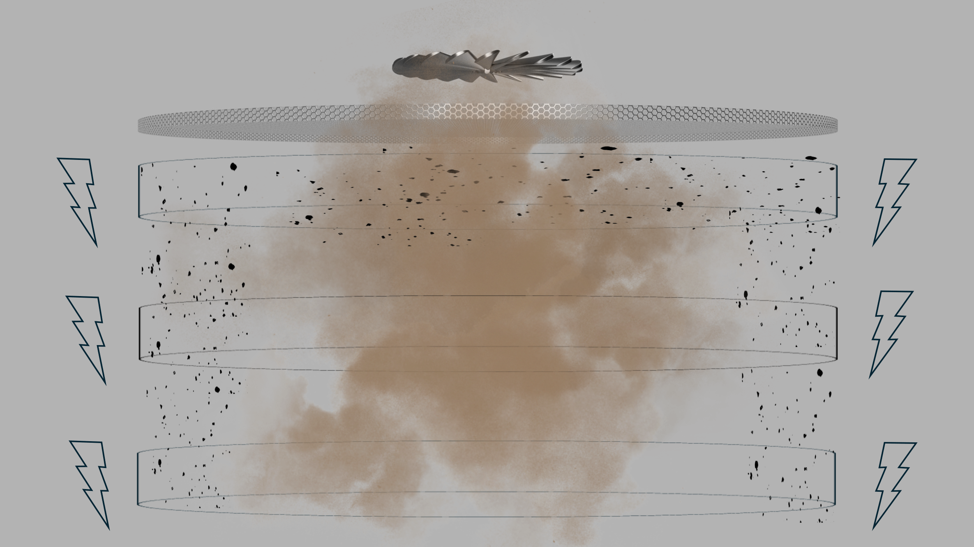
Figure 3 Static Charge

Prototype Education
Once a suitable Scaled-Down Prototype has been developed, education begins. Educating the General Public on the importance of Contaminated Soils is important. However, a concentrated focus regarding the Education system of students is primary. Involving schools regarding the Staticomatic Project could be a powerful way to raise awareness, educate students, and foster community engagement. Here are some strategies to achieve a collaboration.
Educational Workshops:
Collaborate with teachers and school administrators to organize workshops or presentations about plastic pollution, soil health, and the role of Staticomatic. Explain the science behind Staticomatic in an accessible manner, emphasizing its impact on the environment. Use interactive demonstrations or videos to engage students.
Curriculum Integration:
Work with educators to incorporate Staticomatic-related topics into the curriculum. Design lesson plans that align with science, environmental studies, or technology classes. Include hands-on activities or experiments related to plastic removal and soil health.
Student Projects:
Encourage students to undertake projects related to plastic pollution.
Community Outreach:
Involve students in community cleanup drives. They can collect plastic waste from local parks, streets, or beaches. Connect these efforts to the broader context of Staticomatic’s mission. Celebrate their contributions and recognize their impact.
Guest Speakers and Experts:
Invite environmental experts, scientists, or engineers associated with Industry to speak at school assemblies or career days. Hearing from professionals adds credibility and inspires students.
Partnerships:
Partner with schools for joint initiatives. For instance, organize a Plastic-Free Week where students pledge to reduce single-use plastics. Collaborate on research projects or data collection related to soil quality and plastic content.
Competitions:
- Host competitions related to plastic reduction.
- Design a Sustainable Device.
- Create a Plastic-Free School Zone
A good Example of a Designed Sustainable Device is ROONTECH’s Compress-E-Bin, which is a Bagless Volume Reducing Recycle Bin.
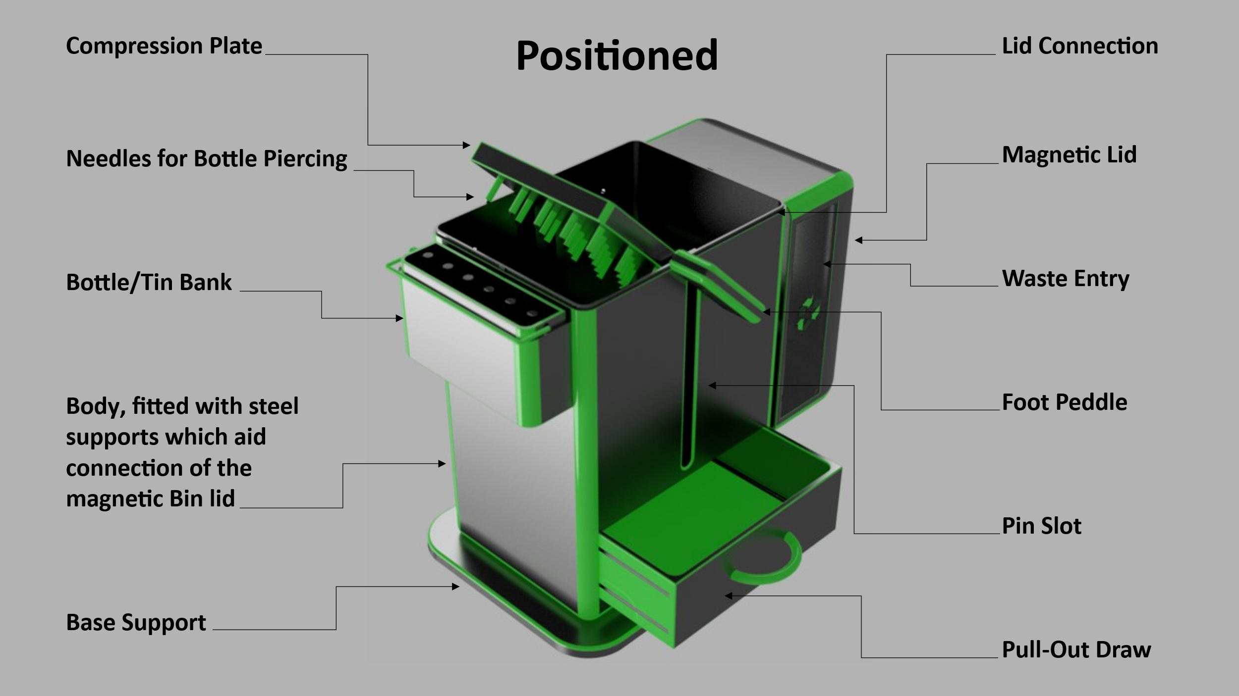
Figure 4 Compress-E-Bin
Long-Term Engagement:
Establish a student-led environmental club focused on sustainability. Regularly update schools on Staticomatic’s progress and share success stories. Remember, involving schools not only benefits the project but also empowers the next generation to become environmental stewards. Researchers have been diligently studying the global issue of plastic contamination in agricultural soils due to the known effects of plastics on the soil ecosystem.

Funding & Cost
The Cost for materials to develop a Prototype depend on the size. For practical purposes, demonstration, materials and equipment availability, I believe something in the dimensional region of a metre cubed is feasible which also aids transportation. With this set Parameter in place a cost of £5000 will cover all aspects and a further £5000, for my time testing including further research. If you or your organisation is interested in this Project, the costs associated can be broken down into segments.

Conclusion
I believe the Staticomatic to be a significant aid to farmers and agriculture. I believe it to transform the industry for the greater good. Static electricity will play a vital role in contaminant separation which increases the survival rate of our species. The cost of this Prototype development is a small price to pay to demonstrate a device that could reduce contaminated Solis dramatically. The educational benefits encourage todays and future generations to think outside of the box, become sustainable and efficient in personal growth and mentality. It would help them understand the importance of Soil and hopefully they can improve the system so that it will not only remove contaminates but replenish the soil with nutrients.

