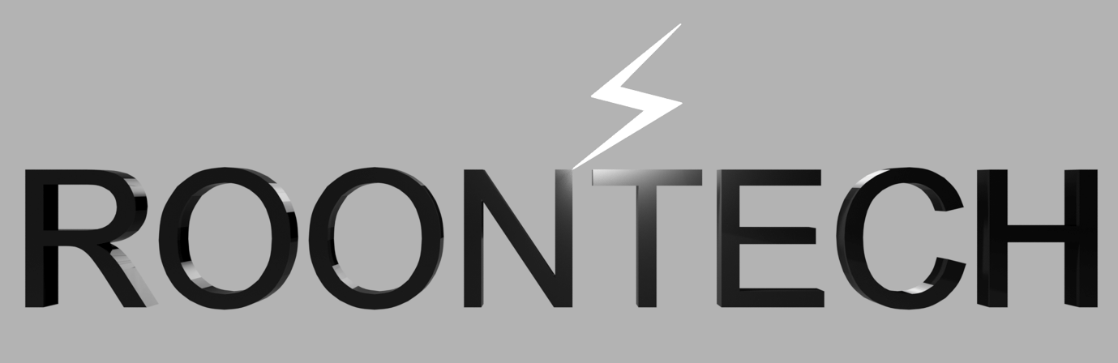

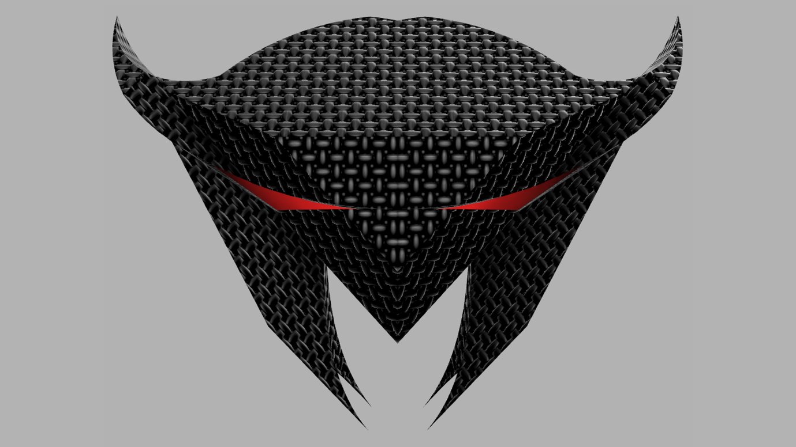

This report is based on factual evidence that supports the Research & Development of utilising Microwave & Laser Beam Technology as a method of wirelessly powering UAVs.

Copyright © 2026 (All Rights Reserved)
Author: Christopher John Rooney (BSc)
Illustrations: Grok

Space-Based Earth Aircraft Power (SBEAP)
Is a forward-looking system concept designed to collect solar energy in orbit and deliver it continuously to high-altitude aircraft via microwave or laser beams. The system envisions a constellation of satellites equipped with large solar arrays that harvest sunlight without interruption from weather, night, or atmospheric conditions.
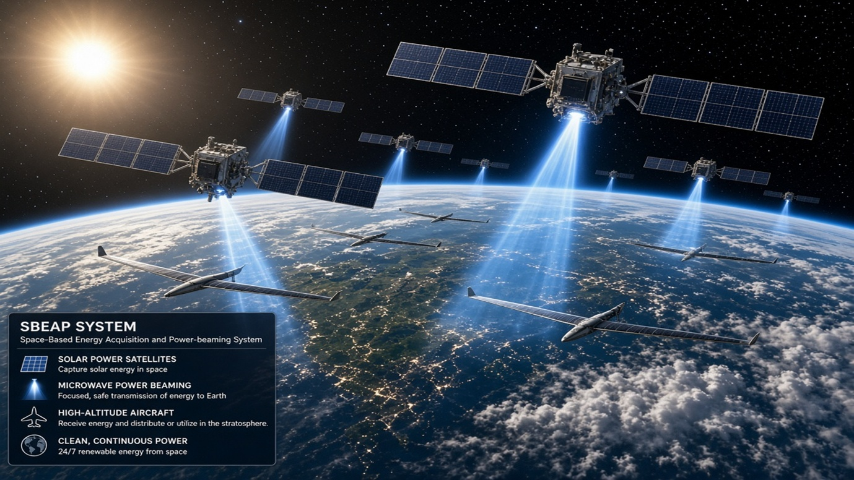
These satellites convert solar energy into focused microwave and laser beams. Both beam types prevent power-dips especially when the handshake between satellites occurs. This ensures uninterrupted energy delivery, enabling persistent, fuel-free flight and near-global coverage. Microwaves penetrate through clouds and storms whilst lasers are used for efficient clearer skies. The system will decide which method is preferred in real time. Both methods can transmit power to aircrafts/UAVs equipped with rectennas and rectifying antennas which are integrated into the wings or undersides.
Core Mechanism
Component | Function
Solar Satellites | Collect solar energy continuously in orbit.
Energy Conversion | Transform sunlight into microwave or laser beams.
Transmission | Direct focused beams through the atmosphere to aircraft.
Rectenna Systems | Receive and convert microwave energy into electrical power.

System Advantages
- Continuous Power Supply: Independent of local weather or daylight.
- Extended Endurance: Enables long-duration, high-altitude operations.
- Reduced Fuel Dependency: Minimises onboard fuel or battery mass.
- Scalable Architecture: Multiple satellites can serve multiple aircraft.
- Environmental Benefits: Potential reduction in aviation fuel use and emissions.
Technical Foundations
SBEAP builds upon decades of space-based solar power (SBSP) research, dating back to the 1970s. Demonstrations of power beaming both microwave and laser have already occurred at smaller scales, including:
- Ground-to-aircraft and aircraft-to-ground experiments.
- In-orbit microwave power transfer tests (e.g., Caltech’s MAPLE).
- Concepts for powering high-altitude platforms (HAPs), drones, and future electric aircraft.
Microwave frequencies between 2–10 GHz are preferred for their ability to pass through clouds effectively. However, challenges remain in beam focusing, atmospheric losses, safety limits, and overall efficiency. Thus, the introduction of laser beams.
Engineering Challenges
To realise SBEAP, advances are needed in:
- Lightweight, high-efficiency solar arrays and RF converters in space.
- Precise beam steering and focusing over long distances.
- Efficient, low-drag rectenna integration on aircraft.
- Improved end-to-end efficiency and cost-effectiveness.
- Compliance with regulatory spectrum and safety standards.
Real-World Context
SBEAP represents an evolution of earlier microwave-powered aircraft concepts and modern studies exploring space-to-aircraft or space-to-HAP power links. It fits within a broader vision of multi-layered energy networks integrating space, air, and ground systems for sustainable global power delivery.

Conclusion
Space-Based Earth Aircraft Power (SBEAP) offers a compelling vision for the future of clean, continuous aviation energy. By merging space-based solar collection with advanced wireless power transmission, it could enable a new era of persistent, fuel-free flight, transforming both aerospace operations and global energy sustainability.
