Space-Based Earth Aircraft Power (SBEAP) is a conceptual system for collecting solar energy in orbit and delivering it continuously via focused microwave beams to high-altitude aircraft equipped with rectennas (rectifying antennas).
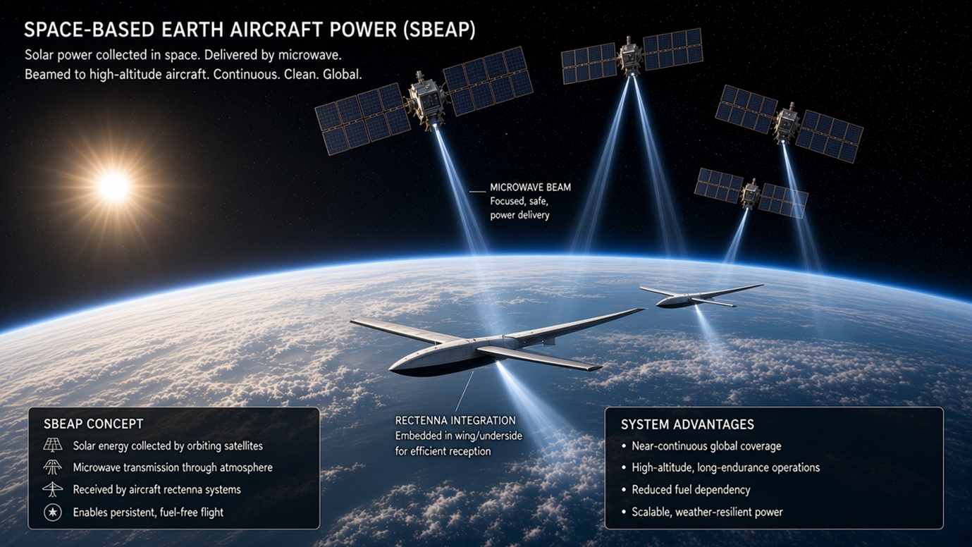
Core Idea
- Orbiting satellites with large solar arrays collect sunlight (uninterrupted by weather, night, or atmosphere).
- Energy is converted and transmitted as focused microwave beams through the atmosphere.
- High-altitude, long-endurance aircraft receive the power via rectennas integrated into the wings or underside, converting microwaves back to electricity for propulsion and systems.
- Result: persistent, fuel-free (or greatly reduced-fuel) flight with near-continuous global coverage potential.
Labelled elements match standard wireless power transfer concepts:
- Microwave beam described as “Focused, safe, power delivery.”
- Rectenna integration for efficient reception.
- Advantages listed: near-continuous global coverage, high-altitude long-endurance operations, reduced fuel dependency, scalable and weather-resilient power.

Related Real-World Context
This builds on space-based solar power (SBSP/SSP) research, which has existed since the 1970s and has seen renewed interest. Power beaming (microwave or laser) has been demonstrated at smaller scales, including:
- Ground-to-aircraft and aircraft-to-ground experiments.
- In-orbit microwave power transfer tests (e.g., Caltech’s MAPLE).
- Concepts for powering high-altitude platforms (HAPs), drones, or future electric aircraft from space or ground transmitters.
Microwave frequencies (typically in the 2–10 GHz range or higher in some designs) are favoured because they pass through clouds relatively well compared with lasers, though atmospheric losses, beam focusing (via phased arrays), safety (power density limits for aircraft, birds, and ground), and efficiency remain key engineering challenges.
System Advantages Highlighted
- Continuous power independent of local weather or daylight at the aircraft’s location.
- Enables long-endurance high-altitude operations without large onboard fuel or battery mass.
- Scalable architecture (multiple satellites serving multiple aircraft).
- Potential reduction in aviation fuel use and emissions for suitable platforms.
Practical Considerations
Feasibility depends on advances in:
- Lightweight, high-efficiency solar arrays and RF converters in space.
- Precise beam steering and focusing over long distances.
- Lightweight, high-efficiency rectennas on aircraft that do not excessively increase drag or structural weight.
- Overall end-to-end efficiency and economics (launch costs, satellite mass, regulatory spectrum and safety rules).
Related historical work includes microwave-powered aircraft concepts (ground-based transmitters powering long-endurance UAVs) and more recent studies exploring space-to-aircraft or space-to-HAP power links as part of broader multi-layer energy networks.
The illustration presents a clean, idealized vision of the concept. Actual implementation would involve significant technology maturation in power beaming, space systems, and aviation integration. Let me know if you’d like a deeper dive into any specific aspect (physics of microwave beaming, efficiency estimates, comparison to laser beaming, existing demos, etc.).
